**Food Byte Grocery**

###### MUHAMMAD BILAL

###### MUHAMMAD AFSHAL



**Session 2017-2021**

Department of Computer Science

COMSATS University Islamabad

ATTOCK – PAKISTAN

Contents

Introduction 8

Literature Review 11

2 Literature Review 12

There have been hundreds of applications developed in which mostly involved in the hospital management system, smart health prediction, patient tracker. There are many software's for management task or only for patient or hospitals. 12

2.1 Existing Apps: 12

2.1.1 FoodPanda 12

Features: 12

2.1.2 Wish 13

Shoppers can directly purchase from the manufactures through Wish. Even though there is no middle man, the price is low and the quality is same as that we buy from shops. 13

Features: 13

2.2 Comparison Table with Pervious systems 13

2.3 Conclusion 13

Proposed Methodology 14

3.1 Non Functional requirements: 15

3.1.1 Performance 15

3.1.2 Response time 15

3.1.3 Security 15

3.1.4 Usability 15

3.2 Functional requirements: 15

3.3 Proposed Solution 15

Project Design 17

4.1.1 Activity Diagram of User 19

4.2 Use Case Diagram 22

4.4Sequence Diagram 24

4.4.1 Sequence Diagram of User 24

Chapter 5 27

Implementation 27

5.1 Implementation 28

5.2 Tools and Technologies 28

5.2.1 Languages 28

5.2.2 Tools 28

5.3 Development Stage 28

5.3.1 System Design 28

5.3.2 App development: 29

5.4 APP Screen Activities 29

5.4.1 Splash Screen 29

Login Screen: 30

Signup Screen: 31

Home Screen: 32

Grocery items: - 33

Cart items: 34

Final Receipt : 35

Profile: - 36

Rider Notification Screen: 37

Admin portal: 38

Mart Dashboard: 39

3. Chapter 6 40

4. Testing 40

6 Testing 41

6.1 Basics of software testing 41

6.1.1 Black Box Testing 41

6.1.2 White Box Testing 41

6.1.3 Unit Testing 42

6.1.4 Function Testing 42

6.2 Objective 42

6.3 Test case results 43

Chapter 7 50

Conclusions and Future Work 50

7.1 Conclusion and Future work 50

7.2 Future work 50

 Submission Form for Final-Year

PROJECT REPORT

|  |  |  |  |  |
| --- | --- | --- | --- | --- |
| **PROJECT ID** |  |  | **NUMBER OF MEMBERS** | 02 |

|  |  |
| --- | --- |
| **TITLE** | Foodbyte |

|  |  |
| --- | --- |
| **SUPERVISOR NAME** | Ma’am Tahira Sadaf |

|  |  |  |
| --- | --- | --- |
| **MEMBER NAME** | **REG. NO.** | **EMAIL ADDRESS** |
| Muhammad Bilal | CIIT/FA17-BCS-014/ATK |  |
| Muhammad Afshal | CIIT/FA17-BCS-029/ATK |  |

**CHECKLIST:**

|  |  |
| --- | --- |
| Number of pages in this report |  |
| I/We have enclosed the soft-copy of this document along-with the codes and scripts created by myself/ourselves | **YES / NO** |
| My/Our supervisor has attested the attached document | **YES / NO** |
| **I/We confirm to state that this project is free from any type of plagiarism and misuse of copyrighted material** | **YES / NO** |

|  |
| --- |
| **MEMBERS’ SIGNATURES** |
|  |
|  |
| Supervisor’s Signature |
|  |

**FINAL APPROVAL**

Certified that we have read this project report submitted by Muhammad Bilal (CIIT/FA17-BCS-014/ATK) and Muhammad Afshal (CIIT/FA17-BCS-029/ATK) and it is, in our judgment, of sufficient standard to warrant its acceptance by Department of Computer Science, COMSATS University Islamabad, Attock Campus, for the BSCS degree.

***Committee:***

1. External Examiner ____________________________

2. Supervisor ____________________________

Ma’am Tahira Sadaf

Professor

Department of Computer Science

Comsats, Attock

3. Head of the Department ____________________________

Dr. Muhammad Tahir

Head of Department

Department of Computer Science

Comsats, Attock

**Declaration**

*“No portion of the work referred to in the dissertation has been submitted in support of an application for another degree or qualification of this or any other university/institute or*

*other institution of learning”.*

**MEMBERS’ SIGNATURES**

**Abstract**

People use internet to know about information in all fields of life. Internet is a very best platform to get information as well as now it has become a way for shopping also. This increase has created a demand for developers to develop an application that provides ease for the people. Foodbyte is basically a system that is developed for both user and rider for comfort and ease. System seems to be an emerging field of computer vision. It is a very challenging task to accomplish a lot of research that is required in this area. In this project we developed a mobile application named as “FoodbByte Grocery”. FoodByte is a grocery shopping android app and web (Portal) App where user can buy grocery items online. This system will be like a virtual supermarket. The purpose of this system is to give benefit and ease to user by saving their precious time. Through this app and website user will be able to get all grocery items on their door step without going to supermarket with carrying heavy bags and waiting in queue outside the shop for your turn. Secondly it will give an opportunity of earning for those riders who will go to supermarket instead of you and also it will be an advertisement platform for the marts that will register themselves on our app. nearest rider to the picking point, will be allocated to the user automatically. Admin will handle the system where he can add or remove items and riders.

**Chapter 1**

# Introduction

* 1. **Introduction**

FoodByte is a grocery shopping android app and web (Portal) App where user can buy grocery items online. Grocery items are displayed in effective graphical user interface. This system will be like a virtual supermarket. Marts are registered on our web portal and their products will be displayed in well graphical way. The purpose of this system is to give benefit and ease to user by saving their precious time. Through this app and website user will be able to get all grocery items on their door step without going to supermarket with carrying heavy bags and waiting in queue outside the shop for your turn. Secondly it will give an opportunity of earning for those riders who will go to supermarket instead of you and also it will be an advertisement platform for the marts that will register themselves on our app. nearest rider to the picking point, will be allocated to the user automatically. Admin will handle the system where he can add or remove items and riders. User will create a list of items in the cart and this will be shared among both user and mart.

**1.2 Objective**

* Providing rider service.
* Earning Opportunity.
* Order made to the registered shopkeepers.
* Machine learning Algorithm for recommendations.
* Nearest rider selection.

**1.3 Modules**

* Home Page: Marts are shown.
* Category: Search for the product in a specific category.
* Search bar: List of products displayed.
* Shopping cart or add to list: Select the product to be purchased.
* Rider selection: Add the selected product to the cart and select Rider.
* Multiple products: Proceed for checkout
* Location: Trace the location of rider, our system will provide nearest to Mart.
* Recommended System: Through ML product would be recommended to user.

**1.4 Problem statement**

Food Byte grocery system to provide a facility to do grocery without going to supermarket, by providing the facility of creating grocery lists, assigning the riders, tracking riders and updating the grocery lists in order to provide services at user’s door step.

**Conclusion**

The concept of our project basically come from online shopping like amazon.com and daraz.pk etc. but the idea of shopping for grocery items online is something new then all that. There are two types of users in our project, one is buyer and the other one is rider which will bring your grocery to your home and there is a middle user among both user and rider that is the Mart where the user will buy groceries. Marts will also register first and after that they can add their products. Buyer will simple register on our system and search items through category like Fruits, Vegetables, and Detergents etc.

Users can buy items from any mart of their choice. After user has checkout the cart, using map nearest rider to that particular mart will be allocated to the user automatically and will deliver items to user on door step. User will have the following benefits.

* Time Saving.
* Providing earning opportunity for rider.
* Ease to find products and ordering.
* Nearest riders will be shown to user for urgent need.

**Chapter 2**

# Literature Review

## 2 Literature Review

## There have been hundreds of applications developed in which mostly involved in the hospital management system, smart health prediction, patient tracker. There are many software's for management task or only for patient or hospitals.

When we searched, we found different types of applications for hospital management system or only for doctor or patient but all are bound for perform specific task.

### 2.1 Existing Apps:

|  |  |  |
| --- | --- | --- |
| **S No** | **Name** | **Functionality** |
| 1 | FoodPanda | For a Single Mart |
| 2 | Wish | No Middle Man |
| 3 | FoodMood | Online Food Delivery |
| 4 | 247Mart | Online Grocery Shopping App in Lahore |
| 5 | Grozar.pk | Online Grocery Store in Gujranwala |

### 2.1.1 FoodPanda

Foodpanda is a mobile food delivery marketplace owned by Berlin-based Company Delivery Hero SE and operates in about 50 countries. It is mostly active in Asia Pacific, Bulgaria and Romania.

## Features:

* For a Particular Mart.
* For baked food.

### 2.1.2 Wish

## Shoppers can directly purchase from the manufactures through Wish. Even though there is no middle man, the price is low and the quality is same as that we buy from shops.

## Features:

* Rider can’t register themselves.
* This is for specific mart.

|  |  |  |  |  |
| --- | --- | --- | --- | --- |
| **Features/Apps** | **Rider Registration** | **Multiple Marts** | **Keep**  **User record** | **Nearest Rider** |
| Food Panda | Yes | No | Yes | No |
| Wish | No | No | No | No |
| Food Mood | No | No | Yes | No |
| Grozer.pk | No | No | No | No |

### 2.2 Comparison Table with Pervious systems

### 2.3 Conclusion

In this chapter, we discuss the previous applications which are related with this app. We compare this application with previous applications. We compare features which are different in this app and discuss all the features which are present in previous apps. We found different applications which are only for one Mart/City for example Foodpanda, 247Mart etc. all are discussed in this chapter.

**Chapter 3**

# Proposed Methodology

## 

## 3.1 Non Functional requirements:

These are the nonfunctional requirements which are described below.

### 3.1.1 Performance

The system will be able to perform all the tasks efficiently. All the features which we introduced in this app are performing all the functionality properly.

### 3.1.2 Response time

The system will be able to respond in few seconds. It is easy to install and take just few seconds to install if your internet availability is much better.

### 3.1.3 Security

All the data will be secured as they will be done through private profiles. Data of all the users is secured in this app. Users are entered in this app with full security.

### 3.1.4 Usability

The application shall be easy enough to be used by any user. This application is helpful to all because grocery buying is the part of daily routine work.

**3.1.5 Testability**

This application is tested all the features like user current location, nearest Mart and Rider.

## 3.2 Functional requirements:

* Initially user will be registered in this app.
* System will automatically get the user location.
* Allow user to choose nearest Mart according to their ease.
* System maintains the database of the Customers.

## 3.3 Proposed Solution

As there is no such facility for the Customers that provides nearest Mart and Rider according to Location therefore, we will develop this android based app in which, when User logins or registers,

They will choose any Mart which is near to their location and where all the desired items are available. Customer will make a List of items, which customer wants to buy. Customer will select the nearest rider, the Item list will be shared with the rider and Mart. Rider will buy these items and deliver these items to customers on their doorstep. Also Customer will pay rider on doorstep.

**3.4 Conclusion**

In this chapter we discuss all the functional and nonfunctional requirements of the system which this app will perform. All the users will be registered in this app and all the data of the users will be secured all the data is maintained of all the Customers in database. This app is helpful for all the users. They get the desired Grocery on their location without any hard work.

**Chapter 4**

# Project Design

**Project Design**

Earlyphase of the project development in the project design is identifying and planning key features, structure, criteria for success, and major deliverable. The objective is to develop one or more designs which can be used to achieve the desired project goals.

* Activity Diagram
* Use Case Diagram
* Context Diagram
* Sequence Diagram

**Methodology:**

All these diagrams are explain below.

**4.1 Activity Diagram**

In this diagram we are showing the graphical representation of workflow of stepwise activities. Overall control of flow is shown in this diagram. Activity diagrams are formed with less number of shapes. The important shapes are:

* Action represented with rounded rectangle.
* Decision represented with diamond.
* Start (split) or end (join) are represented with bars.
* Start represented with black circle.
* End is represented with encircled black circle.
* Arrows show the order of activities in which they are happening.

The activity diagram of user remote support system of all the activities happens in the system to achieve the objective is as follows. This Activity diagram shows how the user will use app from signing in to ordering products.

### 4.1.1 Activity Diagram of User

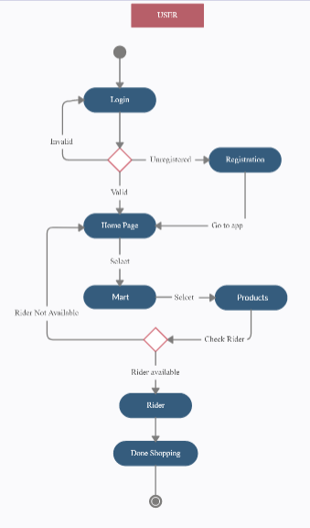

**Figure 4.1 User Process**

User can login and select products which user wants and then select the mart from which user want to buy. After adding items to carts user have to select a rider, who will get those products to door step. If there is no rider available at that time you will back to home screen.

**4.1.2Activity Diagram of Rider Login**

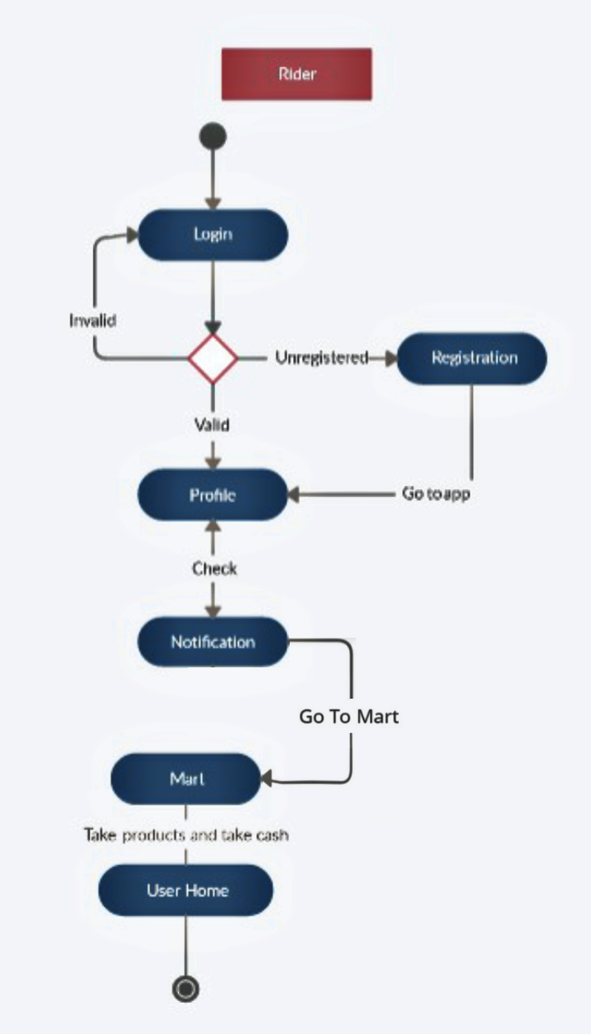

**Figure4.2 Rider login**

Firstly Rider registered themselves in our app, if they are already registered they only login and see their profile and requests.

**4.1.3 Activity Diagram of Mart owner Login**

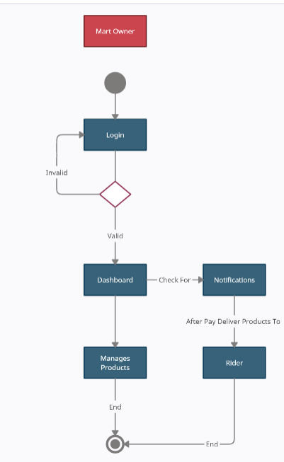

**Figure 4.2 Rider login**

Marts will be registered manually and then marts owner will be given an account which will be handled by mart owner. He can add products only from dashboard on web page.

## 4.2 Use Case Diagram

Use case diagram is used to briefly discuss the requirement of the system. It includes actors, system, user and actions performed by the specified actors. This methodology is used for system analysis and it helps in identifying, clarifying and organizing the system requirements. In our application there are three actors.

* User
* Rider
* Mart owner

Use case diagram contains the following components:

* The boundary is used for identifying the system related with the system actors, users.
* According to the roles the actors are individually involved in the system.
* Use case defines the relationship amongst and between the actors.

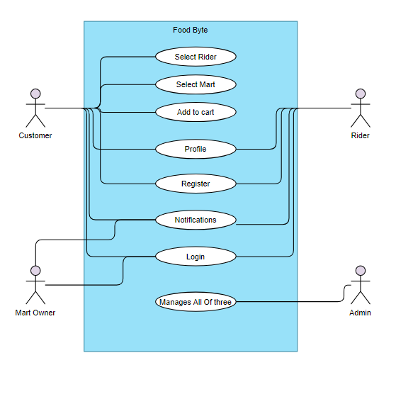

**Figure 4.3 Use Case Diagram**

User will login and select products which user wants and then select the mart from which user want to buy. After adding items to carts user have to select a rider, who will get those products to door step. Rider will have notification and he will visit the particular mart.Mart owner will have user id and order id. Rider will carry out the bag of products and take them to user home.

**4.3 Context diagram**

Context diagram explains the initial level of the software system, which can be further divided into sub portions. In short context, the diagram shows the brief picture of system and its relationship with other entities.

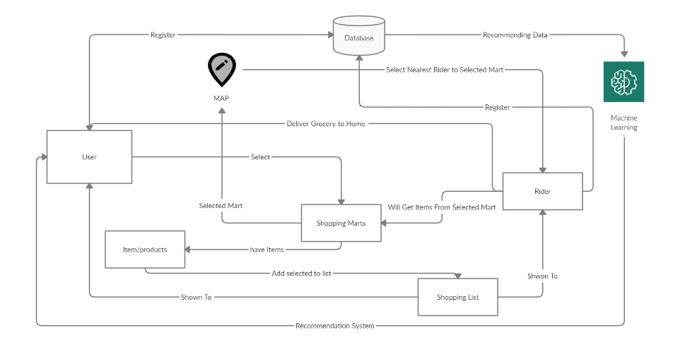

**Figure 4.4 Context Diagram**

User will login and select products which user wants and then select the mart from which user want to buy. After adding items to carts user have to select a rider, who will get those products to door step. Rider will have notification and he will visit the particular mart. Mart owner will have user id and order id. Rider will carry out the bag of products and take them to user home.

## 4.4Sequence Diagram

A sequence diagram is explained in the sequential events of the software system. It is represented through parallel lines which shows the occurring events and at starting and ending have to horizontal lines which shows the system and user respectively.

### 4.4.1 Sequence Diagram of User

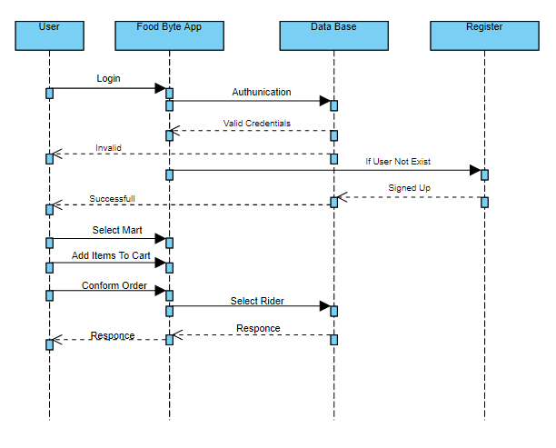

**Figure 4.5 Sequence Diagram of** **User**

Initially Users will register/login themselves. If the user details are valid according to database, then his account will be opened. Users see their information which we put in our app.

**4.4.2Sequence Diagram of Rider**

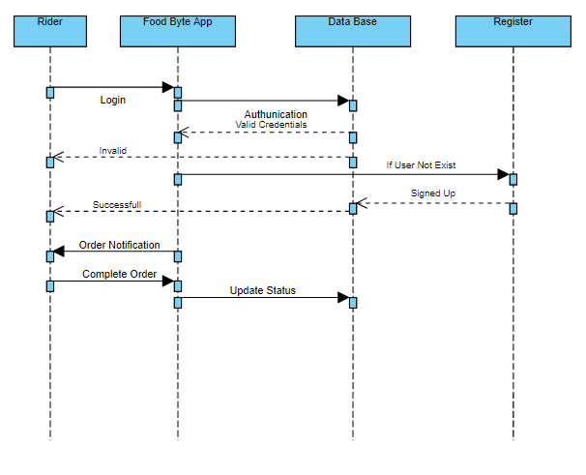

**Figure 4.6 Sequence Diagram of Rider**

Riders will login/register themselves first. In response system will check the details and send the successful message to them. System will send them notification for an order/booking and rider will confirm the availability. Details of the order will be displayed to the rider. Rider will confirm the order and record will be saved in database.

**4.4.3Sequence Diagram of Mart**

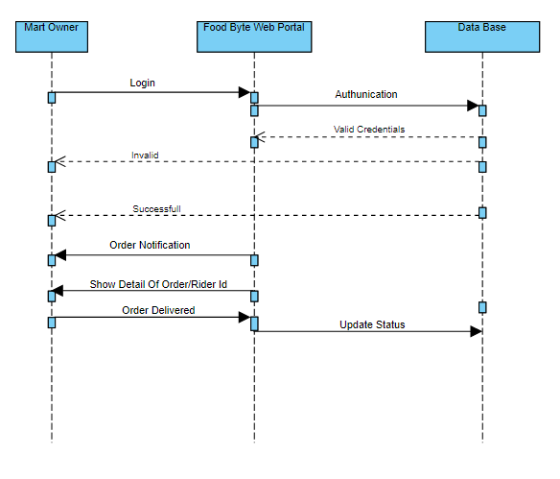

**Figure 4.7 Sequence Diagram of Mart**

Marts will login/register themselves first. In response system will check the details and send the successful message to them. System will send them notification for an order/booking and Mart will confirm the availability. Details of the order will be displayed to the Mart. Mart will confirm the order and record will be saved in database.

**4.5 Conclusion**

In this chapter we discuss all the project design which include the activity diagram, context diagram, use case diagram and sequence diagram. All these diagram explain our project design which we discuss in this chapter. Activity diagram show stepwise explanation of the activities. Sequence diagram show sequential explanation of the system. Use case diagram show the requirements of the system. Context diagram show the initial level of the system.

# Chapter 5

# Implementation

## 5.1 Implementation

In this chapter, we will discuss the tools and technologies used to develop this project. Significance of implementation phase is obvious as it is time to convert an idea into an application. Implementation phase is most challenging phase as it deals with technical complexities. This phase helps a lot in technical learning and improving development skills. An application is a result of a successful implementation.

## 5.2 Tools and Technologies

Below are the tools and technologies that are used to build this project.

### 5.2.1 Languages

* Java
* Php
* Xml
* Html
* Css

### 5.2.2 Tools

* Android Studio
* Sublime text editor
* Pycharm

## 5.3 Development Stage

After clear demonstration of project and development of design document. We further move to implementation phase. To make this dream true.

### 5.3.1 System Design

We design all use cases, sequence diagram and activity diagram for our project. Then we briefly describe how they work.

### 5.3.2 App development:

After making all the design of our application we implemented all source code for app in Android Studio. We implemented all the functionality that we design for our application.

## 5.4 APP Screen Activities

Our application consist of many screens which includes splash screen, login, home and grocery items, cart and user profile.

### 5.4.1 Splash Screen

Splash screens contain a colorful image which is displayed at the start of the application for 3 seconds. It shows the image with a bike rider, which shows that our application is related to online shopping and then delivering the products at doorstep.

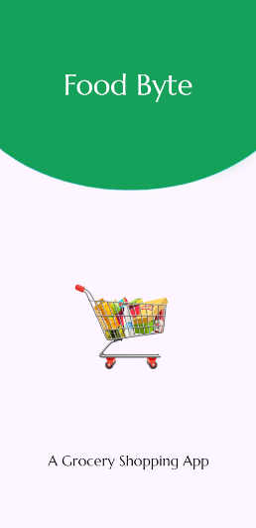

### Login Screen:

After splash screen, login screen will appear. If the user is already registered, use can easily login to application and use it, if it is not registered than it will first register himself/herself, then login and use the application.

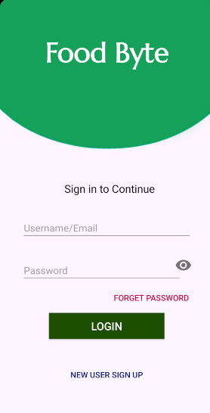

### Signup Screen:

If the user or rider appears first time on the app they can register themselves on this registration page. All the required information would be get through the inputs and rider or user will register successfully.

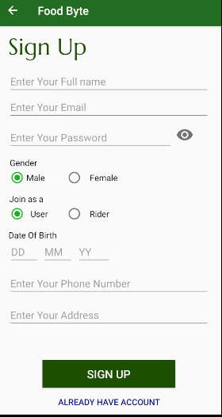

### Home Screen:

It is the screen which will appear after splash screen. In the Top of the screen

Name of our application is written” Foodbyte”. On Home screen three marts and their names are displayed. User can select any mart from them and do online shopping.

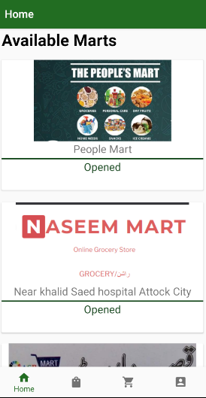

### Grocery items: -

After Home, there is Grocery items screen, where different grocery items are display along with their name, price and description. Add to cart button is also available, through which user can buy that particular product.

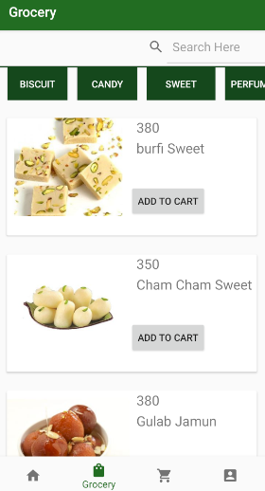

### Cart items:

After Grocery items screen, there is a cart items screen. It contains those items which a user has already bought. It contains Image of the product, name, and price and at the end total bill of that shopping. The top item is recommended item based on last product bought.

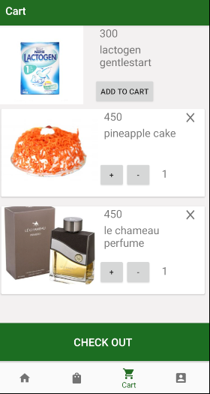

### Final Receipt :

After Cart items screen, there is a final receipt screen. It contains products names and there price. If product quantity is more than one then price will be multiplied with quantity. At the bottom there is total amount for all the products. After user clicked on select rider, nearest rider will be selected and notification will be send to that rider’s account.

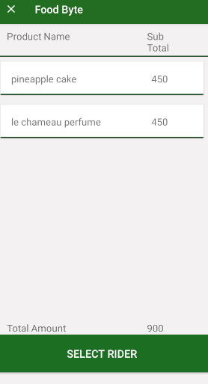

### Profile: -

After cart screen there is a profile screen, where personal information of a user is displayed. User can edit its profile.

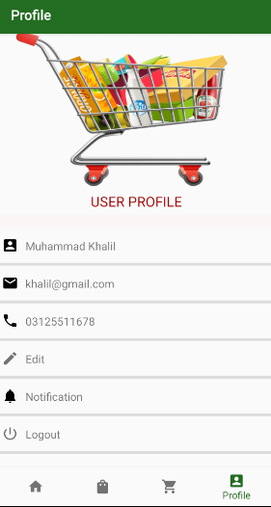

**User Notification:**

A Notification dialogue box is available for user. After user order he/she can know the situation of order. For example order is ready in mart, rider picked up the order etc. 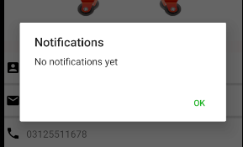

### Rider Notification Screen:

A Notification screen is available for rider, if rider has a new order, this order will appear on notification screen.

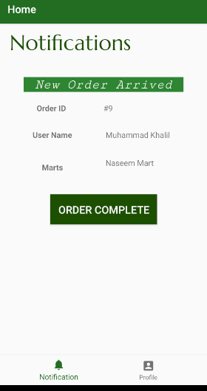

### Admin portal:

On the web side of our application, an admin portal screen is provided where admin will manage all users, marts and riders information. Also Admin can insert a new mart or delete an existing mart.

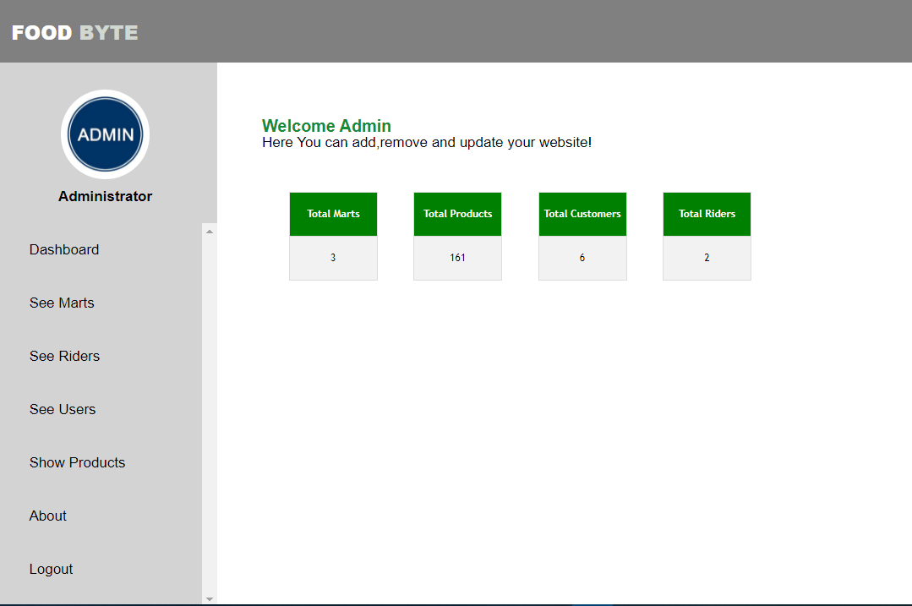

### Mart Dashboard:

A Dashboard is also provided for marts on web side of our application, where marts can insert their new items, delete an item if it is out of stock, and update their items.

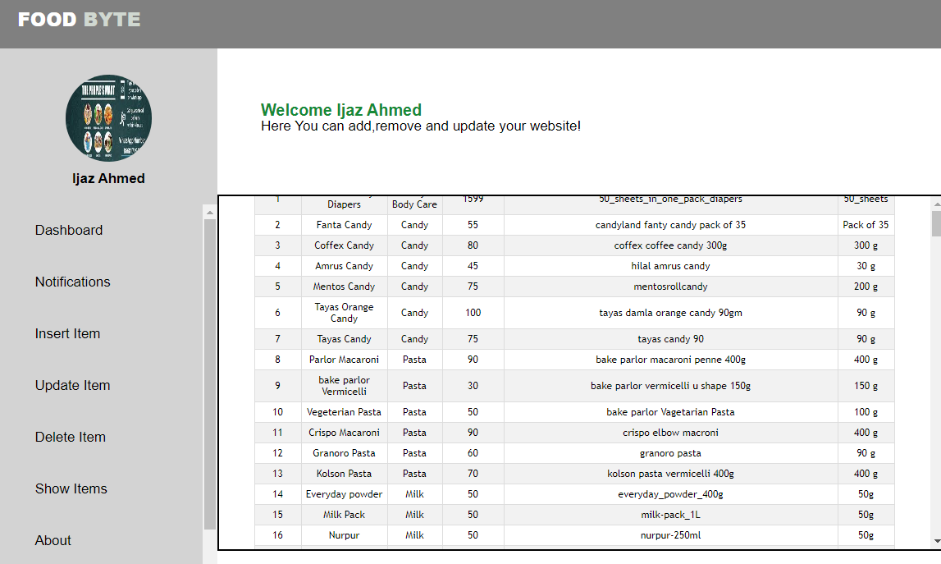

# 3. Chapter 6

# 4. Testing

# 6 Testing

Testing is one of the most important phases in software development. Testing is used to check the stability and conformity of application. We are doing testing to ensure that our app is free of bugs, exceptions and errors. We have tested each module and then we came to know that the application is running without any ambiguity on all android based mobile phones.

## 6.1 Basics of software testing

There are two kinds of software testing,

1. Black box testing.
2. White box testing.

### 6.1.1 Black Box Testing

Black box testing is the technique of testing in which, tester didn’t know the internal structure and block of logic that is being required to test. In black box testing, we only test the validations, constraints, interface testing and responsiveness and usability of a system. We perform this testing technique to check the application activity, its interface and validations on form filling.

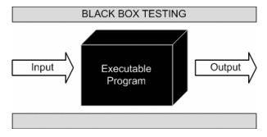

**Figure 6.1 Black Box Testing**

### 6.1.2 White Box Testing

White box testing is another technique used in testing the application. In this technique, tester known the logic and internal structure of system. We use this testing technique to find the logical errors in our application. Control flow of a system and input to output process also test in this testing technique.

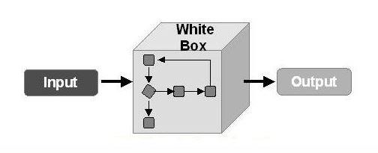

**Figure 6.2 White Box Testing**

### 6.1.3 Unit Testing

The “Foodbyte” has multiple modules and testing is applied on all individual module at the time of development because every module is dependent to each other. Testing applied on all module to check its functionalities or not. Debugger is used to check the code functionalities. We also used exceptions where application crashes due to some issues.

### 6.1.4 Function Testing

In function testing phase, app is going too passed though testing process as a whole to check its working under condition. We also check the interface which look more attractive to the users.

## 6.2 Objective

Primary objective is to ensure that our application is bug free and its performance are as just as we are expecting. “Foodbyte” is an Android and web-based application that is use to do online shopping and saving people time and their energy. To make the app efficient and bug free we apply many testing methods and applying many tests.

## 6.3 Test case results

Test cases are created for each of functional requirement. These tests applied on app to test the functionalities. In our application we make test cases to check the functions of our application working correctly or not.

##### Table 6.1 Test Case (Login)

|  |  |  |  |  |
| --- | --- | --- | --- | --- |
| **Test Case #:** 1.0 **Test Case Name:** Login Screen    **System:** Foodbyte **Subsystem:** Nil  **Designed by:** Muhammad Bilal **Design Date:** 25/11/2020  **Executed by:** Muhammad Afshal **Execution Date**: 27/3/2021  Short **Description:** Get login to use application. | | | | |
| **Steps** | **Actions** | **Expected System Response** | **Pass/fail** | **Comments** |
| 1 | After Launcher Screen | System displays the login screen | pass |  |
| 2 | Enter the correct email and password and tap on login button. | Home Fragment will be opened for performing further tasks | pass |  |
| 3 | If not registered click on new user. | Signup screen will open to get registered. | pass |  |
| 4 | Click on Reset Password Button | System will ask date of birth and if it is correct password will be reset. | pass |  |
| **Post-Conditions:**  • System will display a home screen where different marts will be available.    . | | | | |

**Table 6.2 Test Case (Home Screen)**

|  |  |  |  |  |
| --- | --- | --- | --- | --- |
| **Test Case #:** 2.0 **Test Case Name: Home Screen**  **System:** Foodbyte **Subsystem:** Nil  **Designed by:** Muhammad Bilal **Design Date:** 25/11/2020  **Executed by:** Muhammad Afshal **Execution Date**: 27/3/2021  **Short Description:** Display different marts.  **Pre-Conditions:**  User must be login. | | | | |
| **Steps** | **Actions** | **Expected System Response** | **Pass/fail** | **Comments** |
| 1 | Tap on any mart. | System will display the grocery items of that mart. | pass |  |
| **Post-Conditions:**   * On tapping on any mart, grocery items screen will be displayed. | | | | |

##### Table 6.3 Test Case (Grocery items screen)

**Test Case #:** 3.0 **Test Case Name:** Grocery items screen

**System:** Foodbyte **Subsystem:** Nil

**Designed by:** Muhammad Bilal **Design Date:** 25/11/2020

**Executed by:** Muhammad Afshal **Execution Date**: 27/3/2021

**Short Description:** Display different Grocery items

**Pre-Conditions:**

On home screen, user should one of the provided marts.

|  |  |  |  |  |
| --- | --- | --- | --- | --- |
| **Steps** | **Actions** | **Expected System Response** | **Pass/fail** | **Comments** |
| 1 | Tap the category button | System will display items related to that category. | pass |  |
| 2 | Search item by category. | System will display items related to that category. | pass |  |
| 3 | Click on add to cart button. | That Product will add to user cart. | pass |  |

**Post-Conditions:**

•• on clicking on add to cart button, that product will add to cart and display on cart item screen.

##### Table 6.4 Test Case (Cart Items)

**Test Case #:** 4.0 **Test Case Name:** Cart Items

**System:** Foodbyte **Subsystem:** Nil

**Designed by:** Muhammad Afshal **Design Date:** 25/11/2020

**Executed by:** Muhammad Bilal **Execution Date**: 27/3/2021

**Short Description:** Display cart items

**Pre-Conditions:**

On grocery item screen, user should add some products to cart.

|  |  |  |  |  |
| --- | --- | --- | --- | --- |
| **Steps** | **Actions** | **Expected System Response** | **Pass/fail** | **Comments** |
| 1 | Tap the cart menu. | System will display cart items. | pass |  |
| 2 | Items will be recommended bases on last bought item. | System will recommend the items. | pass |  |
| 3 | Tap on + button | System will increase quantity of that product by 1. | pass |  |
| 4 | Tap on - button | System will decrease quantity of that product by 1. | pass |  |
| 5 | Tap on remove button | System will remove that product from cart. | pass |  |
| **Post-Conditions:**   * On tapping checkout button, system will display a receipt screen involving pricelist. | | | | |

##### Table 6.5 Test Case (receipt screen)

**Test Case #:** 5.0 **Test Case Name:** receipt screen

**System:** Foodbyte **Subsystem:** Nil

**Designed by:** Muhammad Afshal **Design Date:** 25/11/2020

**Executed by: Muhammad Bilal** **Execution Date**: 27/3/2021

**Short Description:** Display receipt of items and pricelist

**Pre-Conditions:**

On tapping checkout button on cart items screen, system will display receipt screen.

|  |  |  |  |  |
| --- | --- | --- | --- | --- |
| **Steps** | **Actions** | **Expected System Response** | **Pass/fail** | **Comments** |
| 1 | Tap the Select Rider button. | System will select the rider nearest to the mart. | pass |  |
| **Post-Conditions:**  • On tapping select rider button, system will select the rider nearest to mart. | | | | |

##### Table 6.6 Test Case (Rider Notification Screen)

|  |  |  |  |  |
| --- | --- | --- | --- | --- |
| **Test Case #:** 6.0 **Test Case Name:** Rider Notification Screen  **System:** Foodbyte **Subsystem:** Nil  **Designed by:** Muhammad Afshal **Design Date:** 25/11/2020    **Executed by:** Muhammad Bilal **Execution Date**: 27/3/2021  **Short Description:** Display New order detail to the rider.    **Pre-Conditions:**  • Rider must be login. | | | | |
| **Steps** | **Actions** | **Expected System Response** | **Pass/fail** | **Comments** |
| 1 | After login, notification screen will appear. | System will display notification if available otherwise display no notification yet. | pass |  |
| 2 | After completing the order, click on order complete button. | System will update the status of that rider and that order to free and completed respectively. | pass |  |

|  |
| --- |
| **Post-Conditions:**  • Click on order complete button, System will update the status of that rider and that order to free and completed respectively. |

# Chapter 7

# Conclusions and Future Work

## 7.1 Conclusion and Future work

In this project, we developed an Android and web-based application for android device. It features a series of Cards (Modules) for the users, where users can view the grocery items available on different marts. Users can buy products from different marts.it helps people to do grocery shopping without physical effort. Rider will bring their required order at their doorsteps

* 6 test cases were generated.
* 6 test cases have generated a PASS.

The developers initially tested all applications. Thus, least mutations are required.

## 7.2 Future work

Several improvements might be possible. Some of thoughts for future progress are: *Adding more marts and more products other than grocery items.

*Adding toys related items for grasping the attention of children.

*Adding feedback Module to get reviews from Users.